***BEEE EVALUATION***

**AIM:**Design a system for LPG gas burners such that, whenever it is turned on, a green LED starts blinking and if it stays on for more than 2000 ms, instead of the green LED, a Red LED starts blinking.

**CIRCUIT DIAGRAM:**

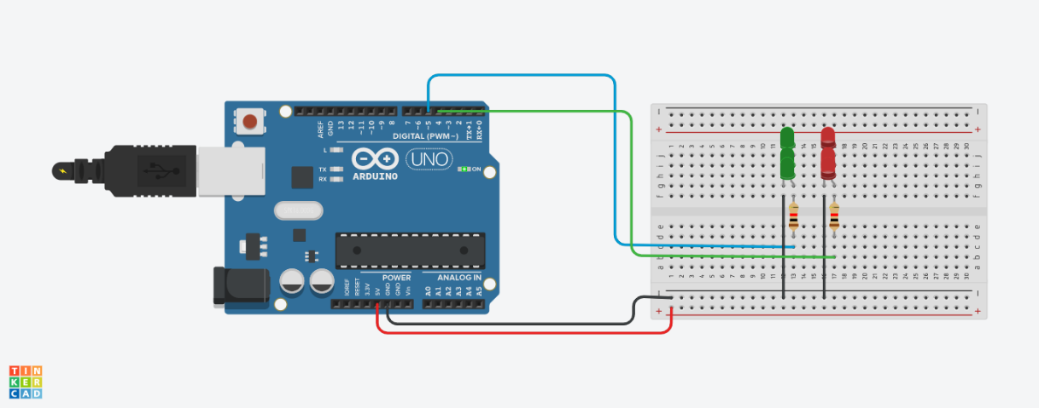

**THEORY**

**CONCEPT USED:** Led flasher,two 1k ohm resistor, two green led,two red led,and ardiuno device is used.

**LEARNING&OBSERVATION:** In this system we learn that green led will blink only one time after 2 ms(milli second) it will off then red led will continue blink

**PROBLEM & TROUBLESHOOTING**

**PRECAUTION:** Make sure connection is correct otherewise it will short.

Make sure your Program is correct otherewise it will not run.

**LEARNING OUTCOMES:**we learn that if we on the gas burner the green led blink after two ms(millisecond) green led will off and red led will blink continues And I learn that our program and circuit connection should be correct otherewise it will not work.